

***Cricketers’ Biographies***

*Project final report*



Daffodil International University

Course Title: Web Engineering

Course Code: CSE417

Submitted To:

Subroto Nag Pinku

Lecturer of Daffodil International University

Department of CSE.

Submitted By:

Lutfunnahar Lubna (162-15-7889)

Daffodil International University

Department of CSE

Submission Date:

August 20, 2019

Project Title: “*CRICKTERS’ BIOGRAPHY*”

Introduction:

This is a web project named “*CRICKTERS’ BIOGRAPHY*”. The people of all classes can use my web page. Using this web page people can find information of cricketers as well as can see information of BCB and whole team. One of the best advantages of this page is that users can see all cricketers all information in a easy way. This chapter highlights the result of the page and the snapshots for each of the activities are shown along with the discussion of each activity describing it’s working. Each snapshot describes every single step of the Crickters biography web page. Users would need to rely on the page. The Cricketers biography page could be the best help in such cases.

Objectives:

The objective of developing such as page for finding cricketers information in an easy way and safe of time in to get a better result. There by increasing the efficiency and decreasing the time. The project provides us the information about cricketers records, various personal information and some important information of BCB whose user want. The web page must provide the flexibility of generating the required documents on screen.

Motivation:

As a young star we have been interested in this field since our interest in game began. We are always interested to know about our favourite players . This project has given us the opportunity to explore the information to find out the answers to our questions.

The Main Features:

The main features of my page are as follow,

1. Cricketers List: In this option there are some information about the cricketers.

i.e. * Name

* Age

* How may match they play

This information will be update and it only depends on user.

1. Home: some pictures and information about Bangladesh cricket Team.
2. BCB: some information about Bangladesh cricket board and president of BCB.

Demonstration (Screen shots):

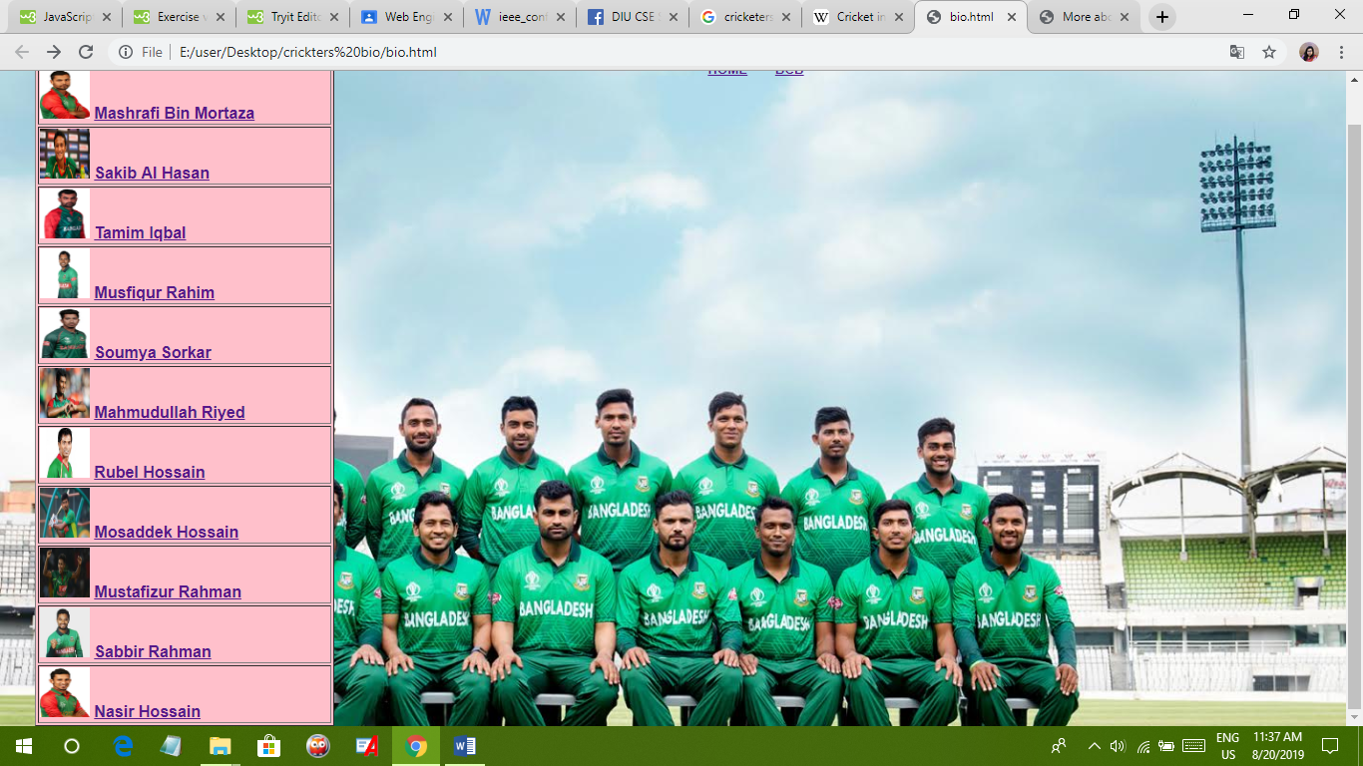

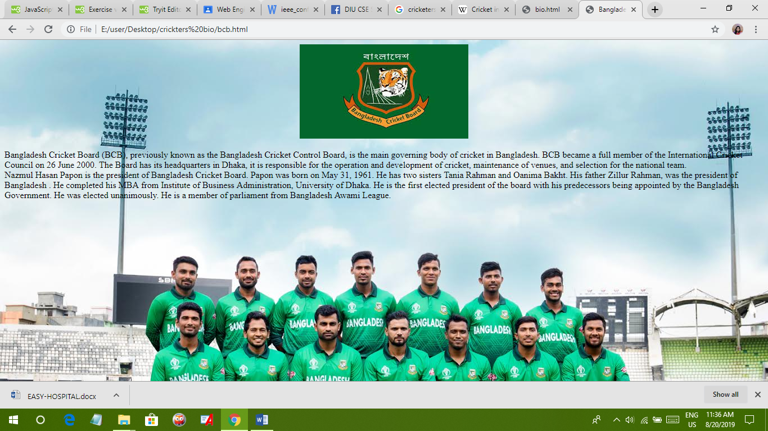

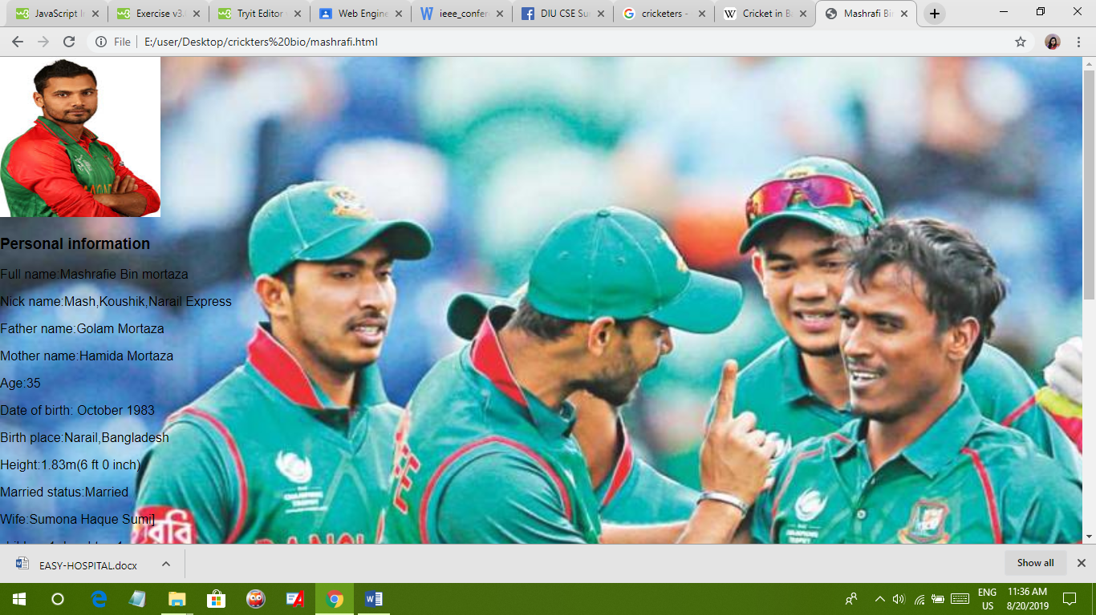

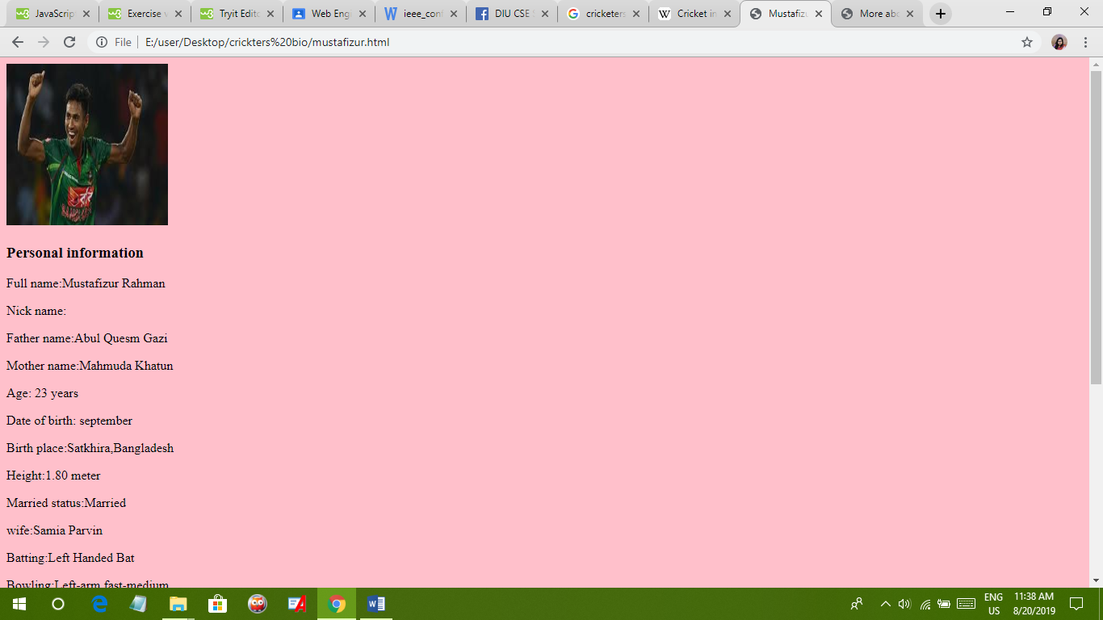

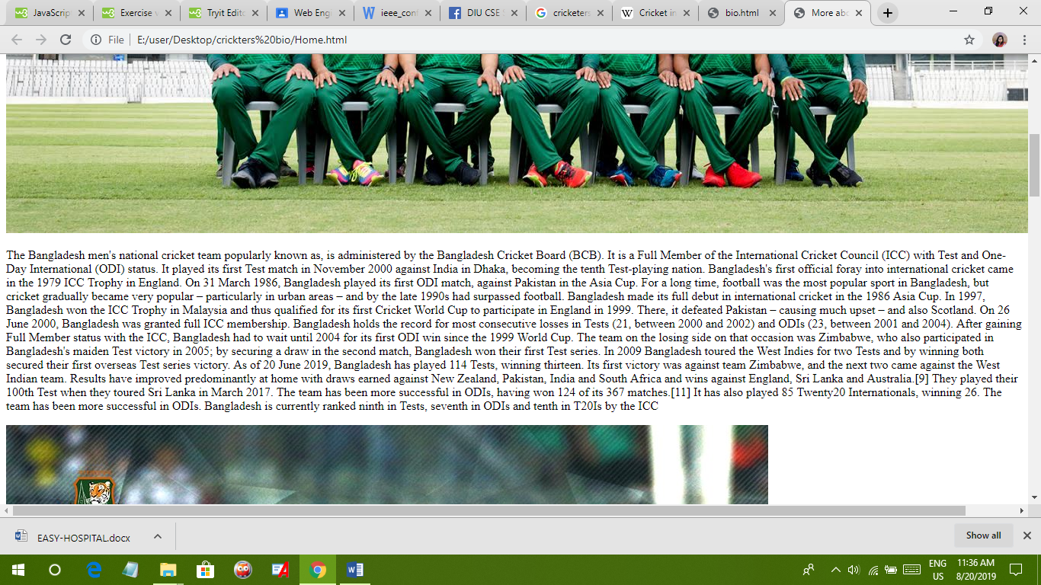

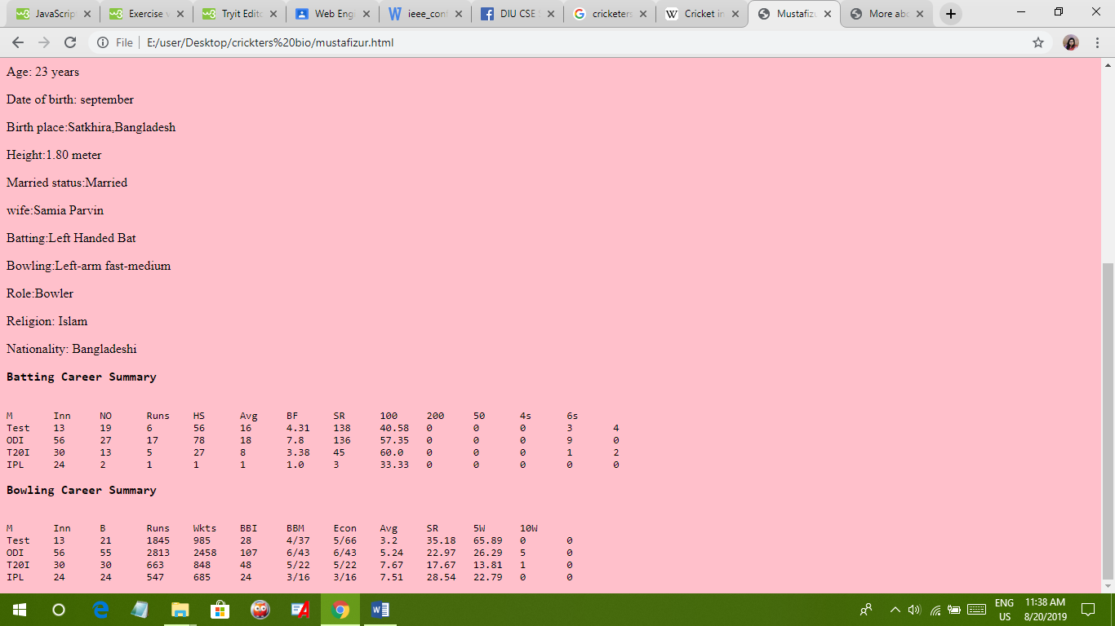

Future Prospective:

In future I will implement some another features like as more cricketers information, live result, comment option, , adding picture, searching option etc.

Conclusion:

This is a very important web page. It will help people to get any cricketers information easily. It will reduce tension of people to finding information and record with a huge time. It will make a young star very closer to game and cricket. So we hope everyone will like my web page and use it with satisfaction.

Reference:

1. <https://en.wikipedia.org/wiki/Bangladesh_national_cricket_team>
2. <http://www.tigercricket.com.bd/about-bcb/>
3. <https://en.wikipedia.org/wiki/List_of_Bangladesh_ODI_cricketers>
4. <https://en.wikipedia.org/wiki/Cricket_in_Bangladesh>